**Network Challenges:**

Here, they provided a PCAPNG file named “captured.pcapng”. Then they asked some questions.

Question No: 01

Which Tools Attacker Used to find vulnerability?

Solution:

Step-01: I downloaded that **PCAPNG** file at first.

Step-02: Opened it with **Notepad++.**

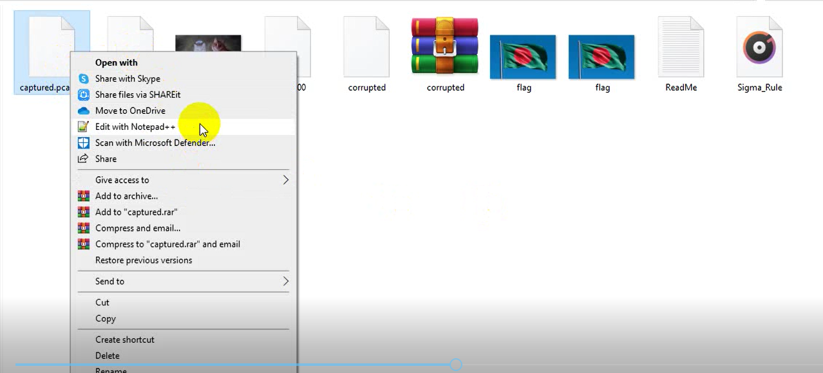

Step-03: Then pressed **Ctrl+F** and opened the search option. Then I read the question again.

As they asked for tool’s name so I

randomly put some known tool’s name **(kismet, nikto, wireshark, nmap…).**

And I found 2 tools name, one is **wireshark** and another is **nmap**.

Step-04: I put there **IIUC{wireshark}** (as it was the flag format) at first. but it was incorrect.

Step-05: Then I tried with **IIUC{nmap}** and It was the correct flag.

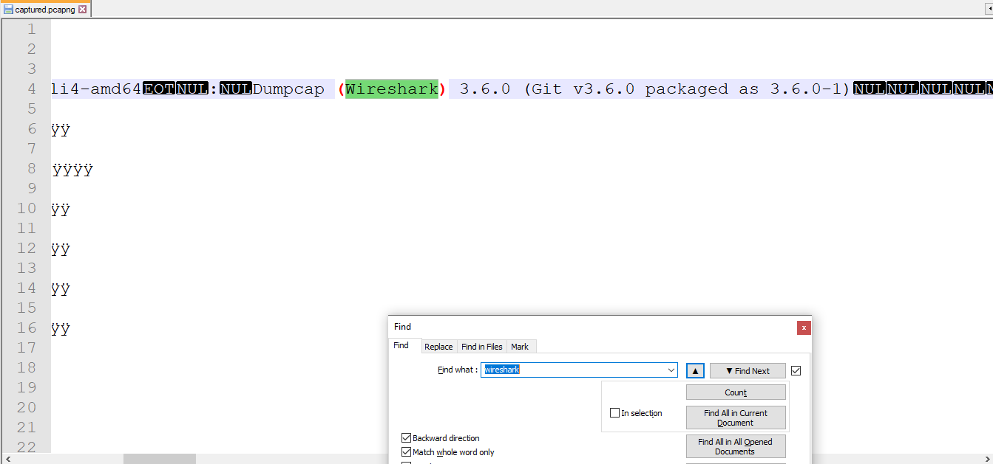

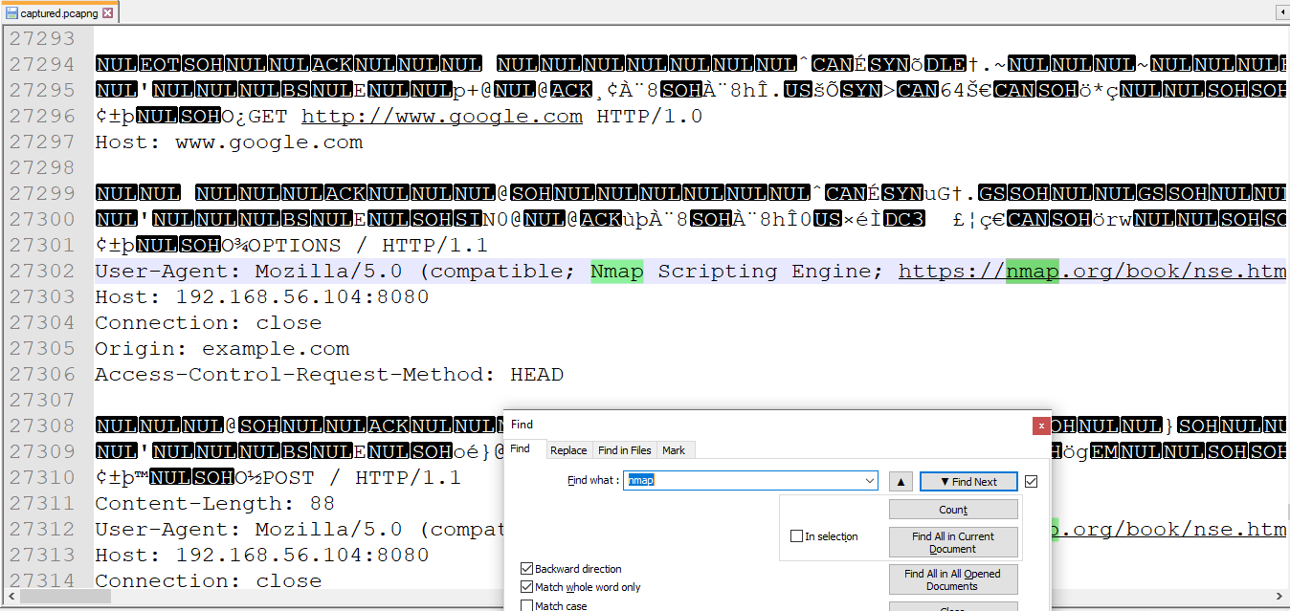

Question No: 02

Which port is running vulnerable service?

Solution:

Step-01: When I solved the first question, I got a host IP address and a port, that is **8080.**

Step-02: So I put that port into the flag format **IIUC{8080}** and it was the correct flag.

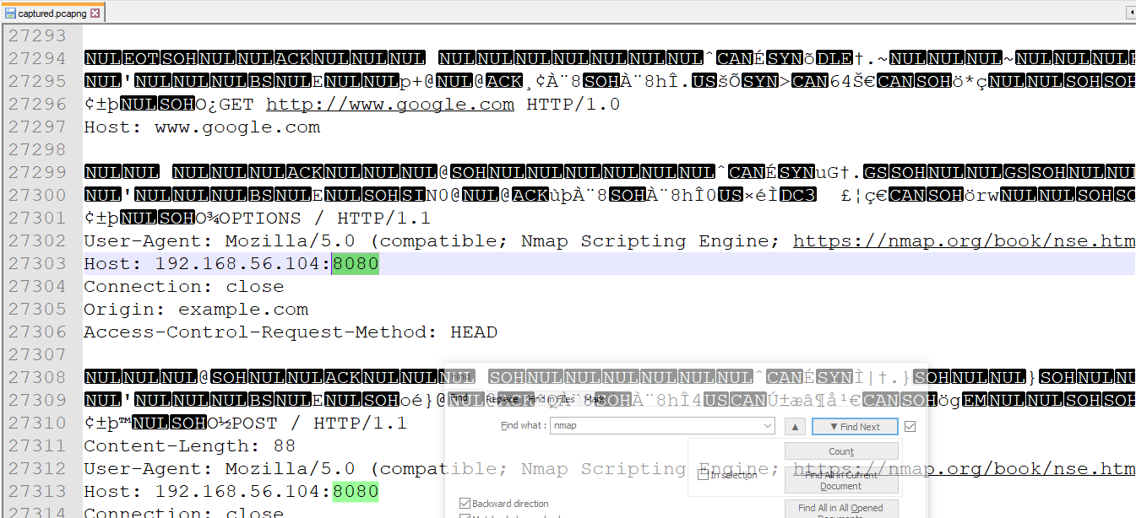

Question No: 04

What is the root flag?

Solution:

Step-01: For the root flag, I searched with the flag format directly as **“IIUC “**and I got a flag which is down to the **“root/flag.txt“** line. The Flag is **IIUC{D0N7_U53_Kn0wN_VuLn3r4BiL17y}.**

Step-02: I just copied the whole flag and pasted it into the submission box and it was correct.

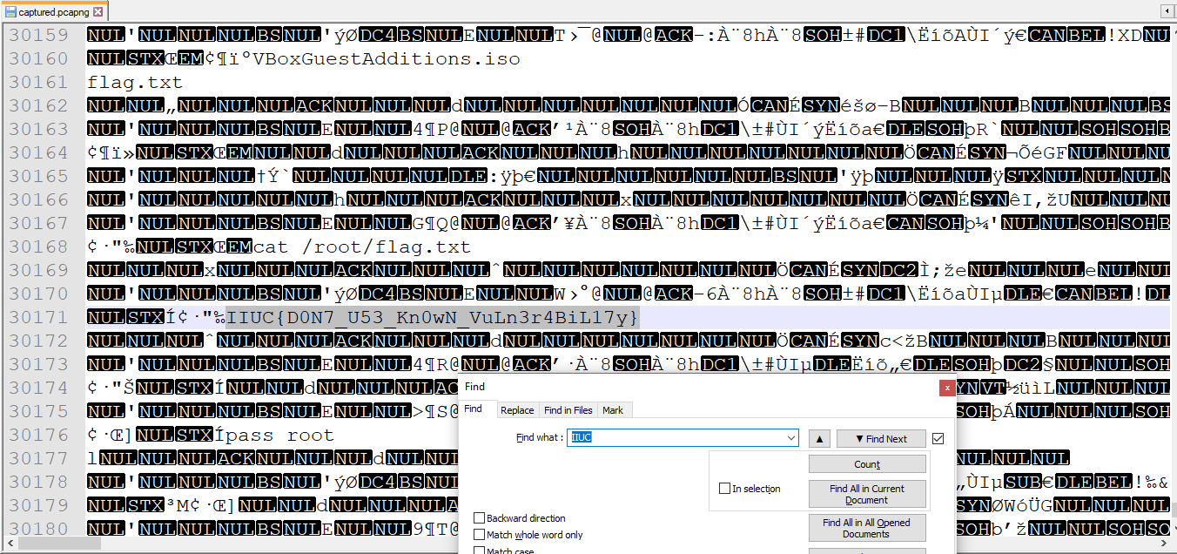

Question No: 06

How many packed captured on this file?

Solution:

Step-01: At first, I opened the file of Question No:01 with **Wireshark**.

Step-02: Then clicked at **Statistics > Capture File Properties.** At the bottom, of **Capture File Properties**, I got some informations of that file including the count of **Packets Captured**.

Step-03: I entered the number into the flag format like this: IIUC{14695} and it was a correct flag.

